CHAPTER 5: Chemical reactions

Worksheet 5.4

Precipitation
Answers

Observing precipitation
1. The following photograph shows the result of adding a colourless solution of lead nitrate to a colourless solution of potassium iodide in a test tube.
Photo: Lindsey Moore Shutterstock.com | 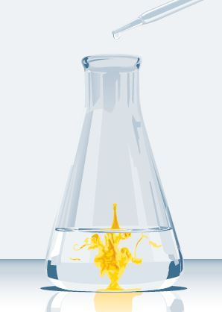 | (a) A yellow precipitate forms. Define the term ‘precipitate’.  An insoluble solid forms when two solutions are mixed.  (b) The test tube is allowed to stand in a rack for 1 hour. What will happen to the precipitate in that time?  The precipitate will settle to form sediment at the bottom of the test tube.
(c) Name the compound making up the precipitate.
Lead iodide

(d) Write a word equation for the reaction.
Lead nitrate + potassium iodide → lead iodide + potassium nitrate

Predicting precipitation
2. The following table provides information on the solubility of various salts in water.
Anion | Soluble | Slightly soluble | Insoluble
Nitrate | All | None | None
Chloride | Most | PbCl₂ | AgCl
Sulfate | Most | CaSO₄, Ag₂SO₄ | BaSO₄, PbSO₄
Carbonate | Na₂CO₃, K₂CO₃, (NH₄)₂CO₃ | None | Most
Hydroxide | NaOH, KOH, NH₄OH, Ba(OH)₂ | Ca(OH)₂ | Most
Use this information to predict whether a precipitate will form when the nominated solutions are mixed. If a precipitate forms, name the precipitate.
(a) Lead nitrate solution + sodium sulfate solution.
Lead sulfate will precipitate (as it is insoluble in water).

(b) Copper(II) sulfate solution + potassium hydroxide solution.
Copper (II) hydroxide will precipitate (as it is insoluble in water).

(c) Barium chloride solution + calcium nitrate solution.
No precipitate forms (barium nitrate and calcium chloride are both soluble in water).

